~ SALE REPORT ~
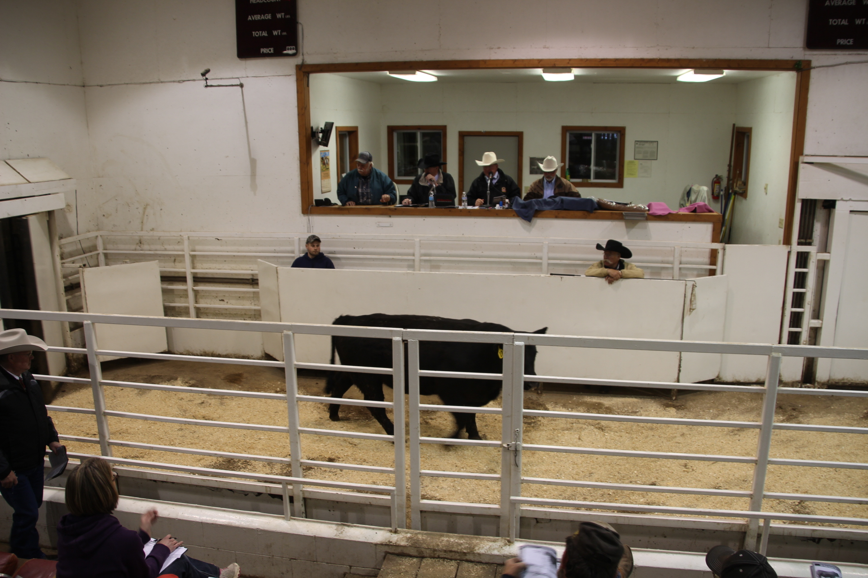

PEARSON ANGUS RANCH PRODUCTION SALE
Fergus Falls, MN April 27, 2014

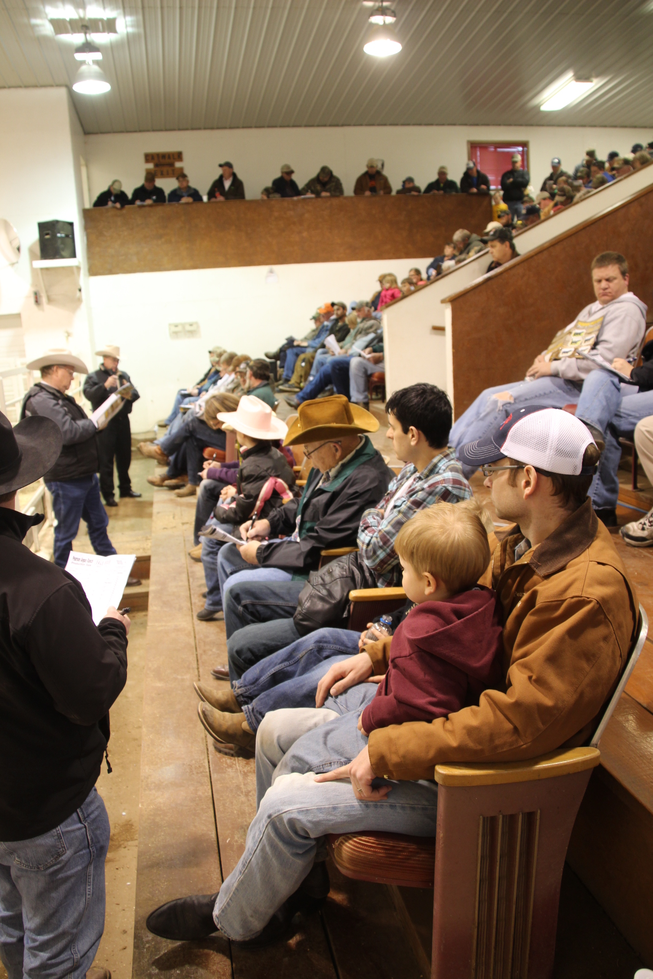
Gross: $252,250

66 Bulls $194,250 $2943
19 Bred Hfrs $ 58,000 $3053

TOP BULLS:
Lot 17 - $5250 Pearson Block Party 126A
A 2-28-13 son of CB Block Party 156. Sold to Points West Angus, Barnesville, MN.

Lot 4 - $4100 Pearson Block Party 102A
A 2-17-13 son of CB Block Party 156. Sold to John DeVore, Park Rapids, MN.

Lot 64 - $4100 Pearson Right Answer P712Z
A 3-24-12 son of Connealy Right Answer 746. Sold to Tracy Waggoner, Bagley, MN.

Lot 15 - $4000 Pearson Block Party 121A
A 2-26-13 son of CB Block Party 156. Sold to Matt Halverson, Baker, MN.

Lot 48 - $4000 Pearson Final Answer 720A
A 4-28-13 son of SAV Final Answer 0035. Sold to Earl Stoltenow, Wahpeton, ND.

Lot 45 - $4000 Pearson Sitz Upward 940A
A 5-5-13 son of Sitz Upward 307R. Sold to Mike Hough, Rothsay, MN.

TOP FEMALES:
Lot 93 - $3500 Pearson Joyce P727Z
A 5-19-12 daughter of Sitz Upward 307R, bred to Pearson Right Answer P712Z. Sold to Riverside Angus Ranch, Osceola, NE.

Lot 94 - $3200 Pearson Lucy P12Z
A 5-22-12 daughter of TC Tycoon 976, bred to Pearson Right Answer P712Z. Sold to Ryan Brenner, Avon, MN.

Volume Bull Buyers: Greg Johnson, Rosholt, SD
John Millar, Sturgis, SD

Volume Female Buyers: Larry Aschema, Hancock, MN
Marlin Nelson, Karlstad, MN

Auctioneer: Col. Al Conover, Baxter, IA

Sale Manager: Conover Auction Service, Al & Jeanne Conover, Baxter, IA

